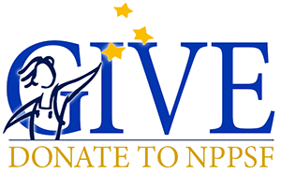
Payroll Deduction Form

I ___________________________________________authorize North Platte Public School District to deduct $______________ per pay period from my payroll for donation to the North Platte Public Schools Foundation.

Employee Signature: _____________________________________
Date: _______________________________

I understand that my donation will continue each pay period until I choose to stop it. I understand that if I wish to cancel my donation I must contact the payroll department directly not the Foundation. If I choose to end my employment or cancel my donation any free item(s) promised by the foundation are forfeited.

In accordance with the provisions of the tax laws regarding charitable contributions, this letter acknowledges the receipt of your gift and may be used for tax purposes. The North Platte Public School Foundation did not provide goods or services in consideration for this gift. Our federal tax identification number is 47-0780300. This organization is a 501c(3) tax-exempt organization, IRS Section 170(b)(2)(iii) for both federal and state tax purposes.

North Platte Public Schools Foundation-301 W F Street-(308) 696-3325-nppsf@nppsd.org

